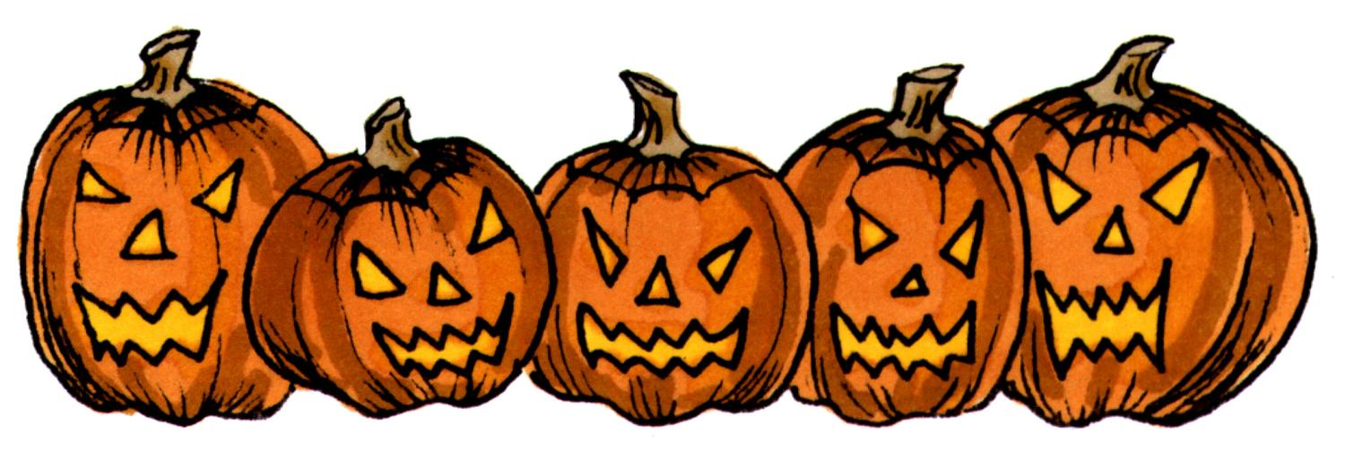
HALLOWEEN ON OUR STREET

Hello Neighbor,

My name is [your name] and I live just down the street from you at [add your street address here] and I’m trying to organize something very special for this coming Halloween night!

We would like to created what is called a "Jack O' Lantern Lane" where both sides of our street is lined with glowing Jack O' Lanterns. To participate all you need to do is carve up to thirteen pumpkins and place them in an evenly spaced line down the front of your property just before sundown on October 31st.. What a wonderful sight this will make!

Need some help? Ask your friends and family to bring one or more Jack O' Lantern’s to add to the street display. If you want to participate but think it might be a bit to much for you, just let me know and I can help out. Be sure to let all your friends and family know that they should come and visit you and see the Jack O' Lantern Lane!

I've asked our local pumpkin patch or grocery store about a group discount for buying pumpkins and they are willing to give us a 10% discount on all the pumpkins we buy from them. You will want to talk to Joe to get the discount.

If you plan on carving a lot of pumpkins, particularly those that use pumpkin carving patterns, you might want to start carving them the night before Halloween, as it can be very time consuming. Jack O' Lanterns should not be placed on the actual street, but just on your property line if possible. Jack O' Lanterns lit with candles should be placed on a cleared area where there is nothing that can catch fire and burn. We highly recommend using votive candles in glass votive candle holders for added safety.

My telephone number is [xxx-xxxx], please give me a call and let me know if you will be taking part in the Jack O’ Lantern Lane.

Thanks again and Happy Halloween,

[John Doe]

Online Halloween Resources
Jack O’ Lantern Lane Article (www.halloween-online.com/party/jack-o-lantern-lane.html)
Pumpkin Carving Tips (www.pumpkincarving101.com)
Lots of Halloween Information (www.halloween-online.com)
List of Halloween Websites (www.halloweenfamily.com)

