SIMULATED “HALLOWEEN COSTUME” X-FILES FBI NAME BADGES

First, you will want to replace the picture of Mulder and Scully with images of yourself. You can either scan a photograph of yourself on a computer scanner or use a digital picture. Crop the image in your favorite picture editing software and then import it into this MS Word document and place it over the current images. You may need to play with the size to get them to over properly. Print out the modified document on your printer and cut out the badges along the black lines. These will fit inside standard 3-1/2” by 2-3/4” plastic name badge holders (available at most office supply stores).
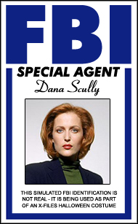
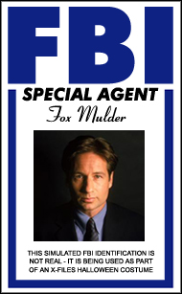

This are simulations only and are intended as part of an X-Files Halloween costume only!

