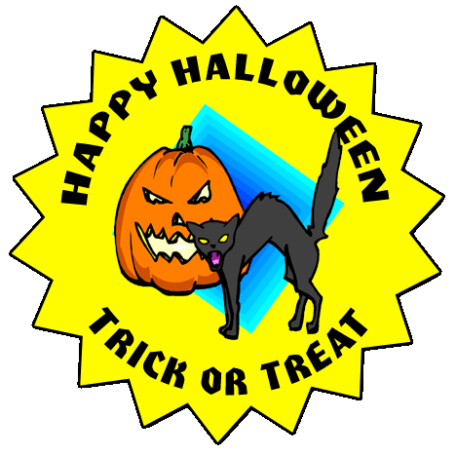
Pumpkin Carving Award
Derek Barnes
_________________________________________________
In recognition of their Pumpkin Carving abilities and outstanding Halloween spirit, the person named below has been awarded this Certificate of Achievement by the Halloween Online Pumpkin Carving Committee for Halloween 2009. Congratulations to Derek Barnes!
Grimsley T. Tombstone
Halloween Committee Member
