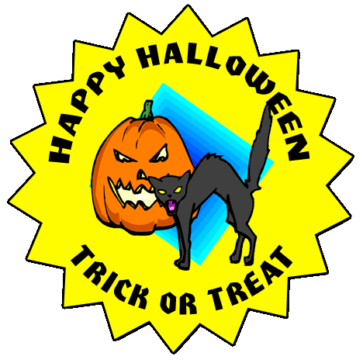
Halloween Costume Award
Chloe Tanner
_________________________________________________
In recognition of their wonderful Halloween costume and outstanding Halloween spirit, the person named below has been awarded this Certificate of Achievement by the Halloween Online Costume Committee for Halloween 2009. Congratulations Chloe Tanner!
Grimsley T. Tombstone
Halloween Committee Member
